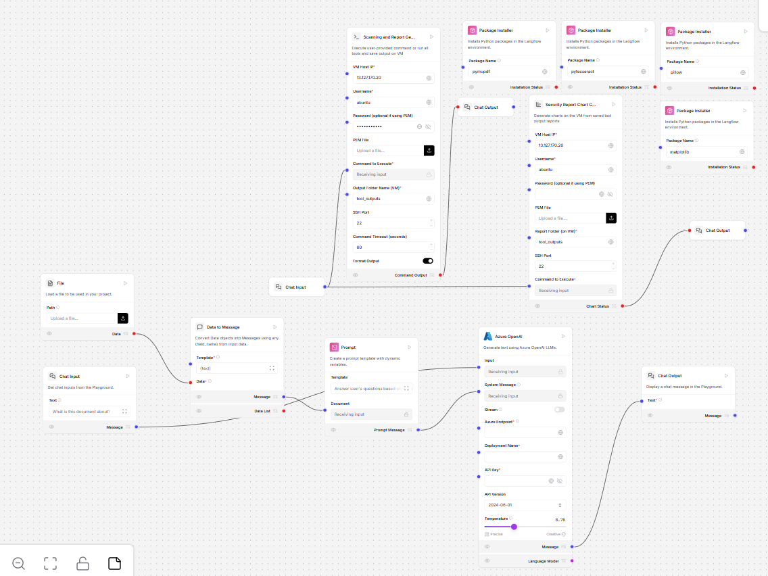

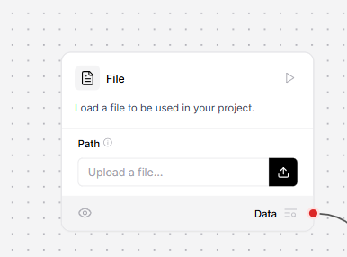

File Component
- Used for: Uploading and reading a file in Langflow
- Purpose: To take the content (text) from the file and send it to the next block
- Supports: .txt, .csv, .json, .zip
- Extra: Can read many files at once (using multithreading)
First block in the flow — without it, Langflow won't know what data to work on.
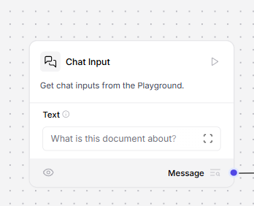

Chat Input Component
→ Used to type a message (your input text)
→ You can also attach a file if you want
→ This message gets passed into the chatbot or agent

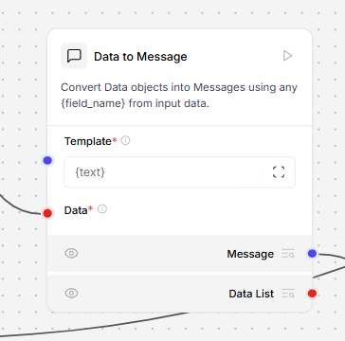

This block formats your file/chat input into proper message(s) so the AI can understand and reply better.

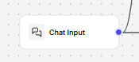
Same as before

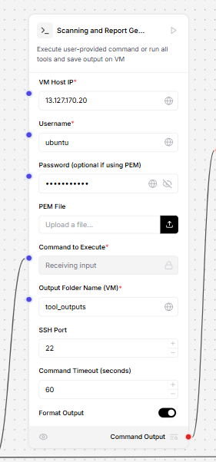
- Connects to a Virtual Machine (VM) using:
  - IP address
  - Username
  - Password or PEM file
- Then it:
  - 🛠️ Runs scanning tools like:
    - Bandit
    - Pylint
    - Flake8
    - K8sGPT
    - Snyk
  - Or ✍️ Executes your own custom command
- 📁 Saves the results in .txt files on the VM in the folder you choose.

- SUMMARY:
📂 File Component
➤ Used to upload files like .txt, .csv, .json, etc.
➤ These files act as input data for further processing.
- 💬 Chat Input Component
➤ You can use multiple Chat Inputs in one flow.
➤ They are used to add any kind of user message or instruction (like “What is this document about?”).
➤ These messages can be connected to other components to help the system know what you want to do with the uploaded data.
- 📨 Data to Message Component
➤ This converts the uploaded file data into a readable message format using a template.
➤ The template can include things like {text} so the AI knows how to display the data.
➤ Example: It prepares the text in a clean, understandable format for the user or for the next AI model.
- 🛡️ Scanning and Report Generator Component (K8sGPTExecutor)
➤ Requires VM credentials like username, password, or PEM file.
➤ It can:
  - Either run your custom command, or
  - Automatically run a group of security tools (like Bandit, Pylint, K8sGPT, etc.).
➤ The output of each tool is saved on the VM in .txt files.

